Quick Story: Product Design Specification

# Team/Project Info

## Project Title: Quick Story

## Team Name: The Librarians

* Nicolas Semaan - Front End
* Kyle Louderback - Database/APIs
* Dexter Estrada - Backend
* Kevin Ngo - Integrations

# Market Space

Quick Story is a website targeted toward parents of young children up to 11 years old. It is designed for generating children's books based on user input. Users can create an account, log in, and submit a form with various details about the characters and settings they want in their book. The application then generates a story and artwork for the book, which the user can preview, download as a PDF, and share on social media.

# Stakeholders

* Parents
  + Quick Story is primarily aimed at parents who wish to read stories for their children. This site is meant to be a convenience to make their lives easier by providing them with a children's story whenever they need one.
* Writers
  + Some writers may think negatively of Quick Story for a variety of reasons, such as how it may compete with their work (and thus jeopardizing their income) or that the AI is generating stories based off of their own works without consent. Other writers may see Quick Story as a tool for brainstorming or quick drafting to help them write their own stories.
* Users interested in AI generation
  + Some users will just want to generate stories out of curiosity or to try and generate funny prompts. These users may try to generate explicit stories or get around restrictions placed on the story generator.

# Features

1. Registration: Allows users to create an account by providing their username, email, and password.
2. Login/Logout: Allows users to log in and out of their account to access the other features of the application.
3. About Page: Provides information about the purpose and functionality of the application.
4. Book Generation: Generates a children's book based on user input, including character names, ages, and story settings.
5. Form: Allows users to input details about the characters and settings they want in their book.
6. Preview: Allows users to preview the book and make changes if necessary.
7. Download: Allows users to download the book as a PDF.
8. Share: Allows users to share the book on social media.

# Feature Sets with Use Case Scenarios

## Registration

* Use Case: A new user visits the site and clicks on the Register link on the homepage. They are taken to the Registration page where they fill out the registration form with their username, email, and password. After submitting the form, the user receives a confirmation message and is redirected to the homepage.

## Login/Logout

* Use Case: A registered user visits the site and clicks on the Login link on the homepage. They are taken to the Login page where they enter their email and password. After successful login, the user is taken to the homepage where they can access the other features of the application. To logout, the user clicks on the Logout link in the navigation bar and is redirected to the homepage.

## About Page

* Use Case: A user wants to know more about the application and clicks on the About link in the navigation bar. They are taken to the About page where they can read information about the application and its features.

## Book Generation

* Use Case: A user is logged in and clicks on the Book link in the navigation bar. They are taken to the Book page where they can input details about the characters and settings they want in their book. After submitting the form, the application generates a children's book based on the user input, including the story and artwork. The user can preview the book, download it as a PDF, or share it on social media.

## Form

* Use Case: A user wants to generate a book and clicks on the Book link in the navigation bar. They are taken to the Book page where they fill out the form with details about the characters and settings they want in their book. The form includes fields for character names, ages, and story settings.

## Preview

* Use Case: After generating a book, the user is taken to the Preview page where they can view the book and make changes if necessary.

## Download

* Use Case: After generating a book, the user is taken to the Preview page where they can download the book as a PDF.

## Share

* Use Case: After generating a book, the user is taken to the Preview page where they can share the book on social media.

# Page Descriptions

1. Home: The homepage of the application, which includes links to the Registration, Login, About, and Book pages.
2. Registration: The registration page, where users can create an account by filling out a form with their username, email, and password.
3. Login: The login page, where registered users can log in by entering their email and password.
4. About: The About page, which provides information about the purpose and functionality of the application.
5. Book: The Book page, where users can input details about the characters and settings they want in their book.
6. Form: The form page, which displays the form that users can fill out to input details about the characters and settings they want in their book.
7. Preview: The Preview page, which displays the generated book and allows users to make changes if necessary.

# UML Diagram

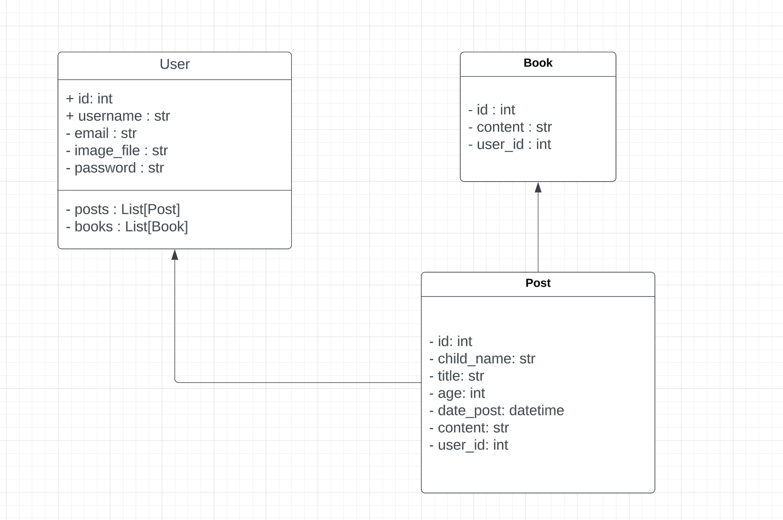

# Testing Plans

1. Registration: Verify that users can successfully create an account by filling out the registration form with their username, email, and password.
2. Login/Logout: Verify that users can successfully log in and out of their account to access the other features of the application.
3. Book Generation: Verify that the application successfully generates a children's book based on user input, including character names, ages, and story settings.
4. Preview: Verify that users can successfully preview the generated book and make changes if necessary.
5. Download: Verify that users can successfully download the generated book as a PDF.
6. Share: Verify that users can successfully share the generated book on social media.

# Major Milestones

* M2: Registration, Login/Logout, About, and Form features - March 5
* M3: Book Generation feature - March 19
* M4: Preview and Download features are completed - March 30
* M5: Share feature is completed.- April 10